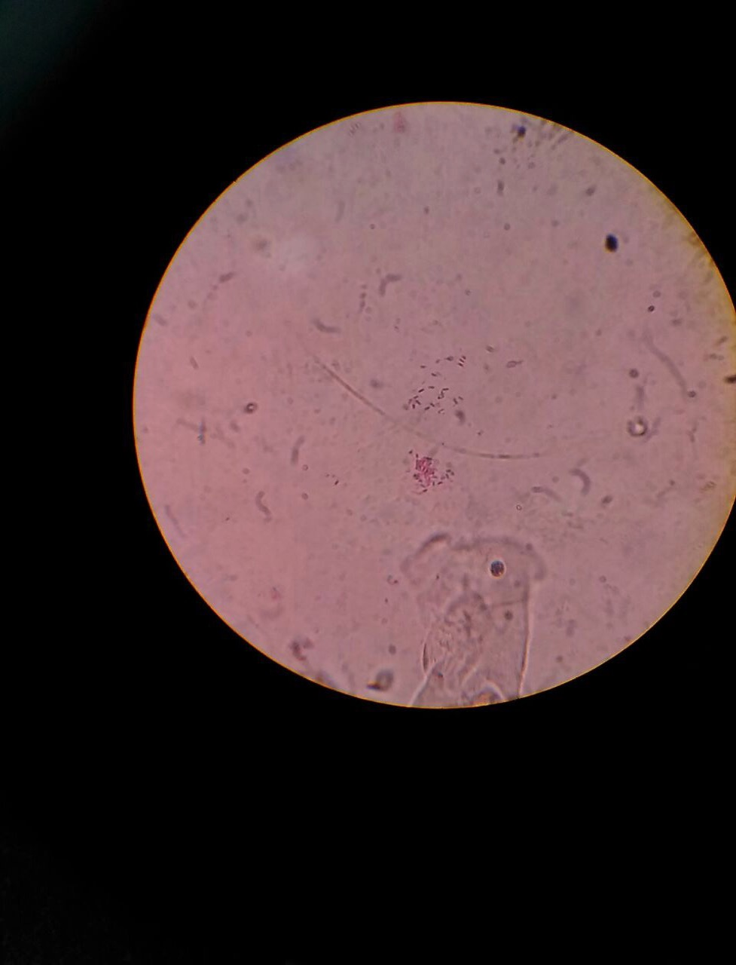

**Virginia iGEM 2016 1**

Introduction to Biocontainment………………................................ 2

Results from iGEM Survey……………………………………………..4

Existing Methods Table…………………......................................…5

Choosing a Method for Your Project…...........................................8

Biocontainment Method Success Checklist...……………………….9

Ethical Considerations…………………………...............................10

US Regulation and the Cartegena Protocol…...........................….11

Additional Resources…………………………………………………12

Image Contributed by SVCE Chennai iGEM Team 2016

Biocontainment: A Primer for iGEM Teams

Purpose

As the field of synthetic biology continues to advance, with many discoveries and novel applications demonstrated by both researchers and iGEM teams, there is an increasing push for implementation in real-world scenarios. However, applying a synthetic biology solution in an open setting (see below for definition) requires consideration of several biological, ethical, and legislative issues. Additionally, since implementation of GMO’s in an open setting can have direct or indirect effects on the public, these dialogues should be open and accessible to non-specialist members of the community. Therefore, biocontainment should be an important consideration when iGEM teams assess impact, scale-up, and public reception. However, results from a survey that Virginia iGEM conducted in September 2016 (see “Survey Results” on page 3) indicate that the definition of biocontainment is either unknown or not agreed upon between and, in some cases, within teams. As such the Virginia iGEM team has generated a specific definition that we hope will be used by future teams in the discussion and understanding of biocontainment (see below). When conducting research of prior literature, the Virginia iGEM team found that timely and accurate information related to biocontainment was difficult to find, not consolidated, and fairly inaccessible. Additionally, several documents concerning this issue, especially concerning policy and ethics, are length and use technical terminology. This pamphlet is designed to:

* educate iGEM teams on the basics of biocontainment and current methods
* provide tools for iGEM teams for selecting and implementing a method
* offer a brief overview of biocontainment legislation
* foster dialogue around ethical issues related to biocontainment
* direct iGEM teams to more comprehensive resources and experts

Although we have consulted with several experts and used other teams’ inputs in

determining the content of this pamphlet, we recognize our lack of expertise in the field. As such, we invite any comments from iGEM teams or other stakeholders to be submitted to virginia.igem@gmail.com. The team will take all comments into careful consideration before submitting the final draft to iGEM headquarters for distribution next year.

Introduction to Biocontainment

Biocontainment (n): the prevention of unintended environment release and effects of genetically-engineered organisms (GEOs) by utilizing the cell’s intrinsic machinery as a regulatory mechanism.

Open setting (n): a setting in which the GEO is able to interact with and affect the natural environment

**Virginia iGEM 2016 2**

Biocontainment is crucial for the expansion of the synthetic biology field. Without it, many synthetic biology projects could never be ethically, environmentally, or financially viable for implementation into ecological systems. The NOAA and NIH require standardized physical containment systems, such as UV radiation and bleach exposure, for all GEO microbiological practices. However, physical containment, designed for laboratory settings, cannot be utilized in environmental settings.

**Virginia iGEM 2016 3**

Imagine that your team has engineered a strain of *E. coli* to degrade oil and you hope to use this GEO to clean up an oil spill in the ocean. While this organism is a perfect tool for bioremediation, indiscriminate introduction of GEOs into natural environments is generally disfavored. In other words, your team would want the organism to die after completing the task so that it doesn’t disrupt the ecosystem in the long-term. In this case, it is impossible and counter-effective to pour bleach into the ocean or irradiate the entire area after the bacteria has done its job. Let’s say that your team would like to restrict the area that the GEOs could live and function as oil cleaners. In this case, you could edit the genome of the organism to confer dependence on a specific substance only present in this area (auxotrophy). A more robust method would be to confer dependence on a substance that is not present in natural environments, your team could control the area of activity through supplementation of this synthetic substance (synthetic auxotrophy or lock and key). If there are a specific set of stimuli that are only available in this environment, you can design a kill switch or gene circuit that will actively kill the organism in the absence of these stimuli. You can even design these switches and circuits to function in response to a signal that the GEO has completed its task. For example, if your bioremediation GEO degrades oil into certain hydrocarbons, a large concentration of these hydrocarbons could activate the kill switch or gene circuit to cause cell death. All of these methods have their own strengths and weaknesses, and can work to serve your specific implementation needs and concerns differently (see “Existing Methods” table and “Choosing a Method for Your Project”). Despite these variations among methods, in the implementation of any method, it is extremely important to consider the ways that the organism can circumvent the system to survive. These three main routes of escape are:

* Mutagenic drift: The GEO ejects or deactivates the biocontainment system due to its metabolic burden or the organism’s decreased fitness. Kill-switches and auxotrophs most often fall prey to this mode of escape. This mode of escape can be overcome by implementing a method that confers a competitive advantage to the GEOs.
* Environmental supplementation: Auxotrophic organisms scavenge the necessary metabolites, needed for their survival, in the environment or from lysed cells. Using synthetic auxotrophies, not found in the environment, can prevent this mode of escape.
* Horizontal gene transfer (HGT): Cells lacking certain survival genes can obtain these genes from wild-type organisms in the environment. This mode of escape can be prevented by utilizing a method that will not be influenced by the presence of any wild-type genes (ex. NSAA, xenobiology, and certain synthetic auxotrophs).

Biocontainment opens the door to possibilities of real-world implementations, and the variety of methods available allow for customization based on the specific organism, its function, and feedback from stakeholders.

Survey Results

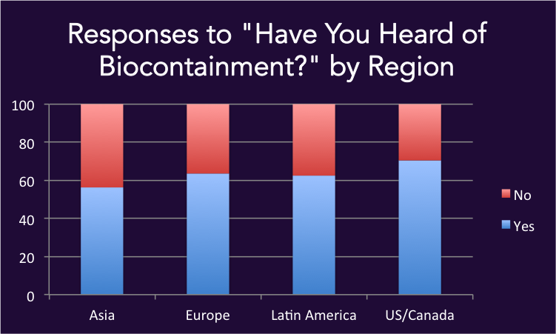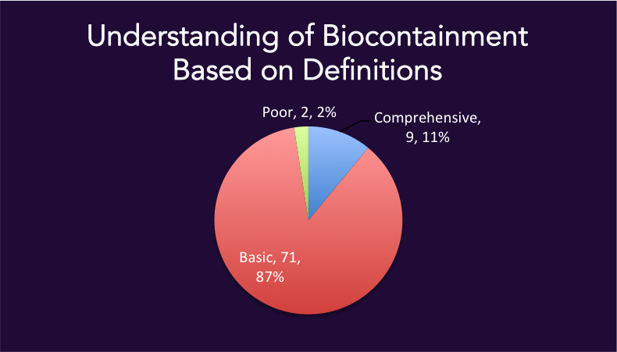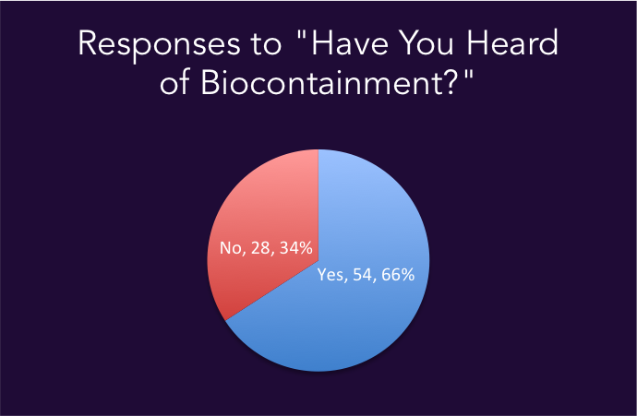Virginia iGEM sent a survey about biocontainment to all 2016 iGEM teams and received 83 responses, 81 of which were used in our data analysis. While over one-third of respondents hadn’t heard of biocontainment, there was no significant differences between regions (Asia, Europe, Latin America, and US/Canada) in response to this question. However, very few respondents had what was deemed to be a comprehensive understanding of biocontainment, which was defined as mentioning the control by intrinsic cellular components. The majority of teams had a basic understanding, which was defined as mentioning anything related to physical containment. In assessing the relevance of biocontainment to their projects, over half of respondents had not considered its use. When asked to rate the importance of various qualities of biocontainment methods from 1 to 5, most qualities were ranked as fairly important (3-4), with translatability being the least important and effectiveness being the most important. The quantitative results of the survey, as well as the in-survey feedback on knowledge gaps informed the creation of this pamphlet. See figures for more detail.

|  |  |
| --- | --- |
| Factor | Average Rating |
| Ease of Implementation | 3.69 |
| Cost of Implementation | 3.62 |
| Ease of Maintaining the Contained Organism in the Environment | 3.74 |
| Cost of Maintaining the Organism in the Environment | 3.51 |
| Effectiveness (i.e. no escapees) | 4.07 |
| Metabolic Burden of the Biocontainment System on the Organism | 3.74 |
| Translatability of the Biocontainment Method Between Different Organisms | 3.20 |
| Ability to Use Biocontainment System in Various Environments | 3.63 |

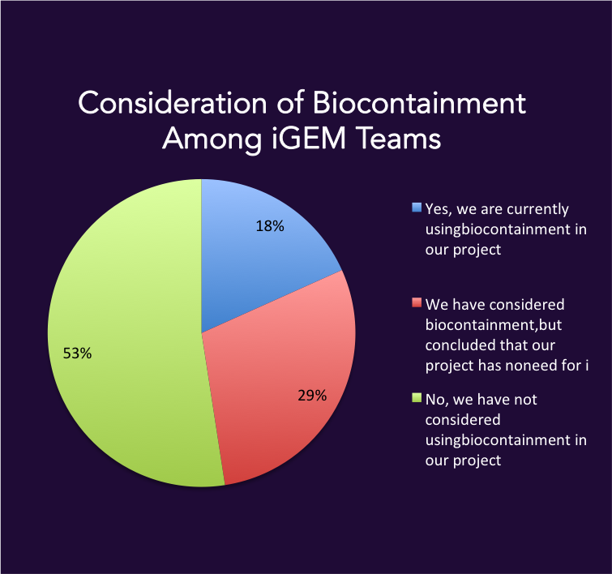

**Virginia iGEM 2016 4**

Existing Methods and Their Strengths and Weaknesses

|  |  |  |  |  |  |  |  |
| --- | --- | --- | --- | --- | --- | --- | --- |
| Biocontainment method | Description | Cost of Implementation | Cost of Upkeep | Ease of use | Prevents mutagenic drift? | Prevents environmental supplementation? | Prevents HGT? |
| Auxotrophs | Auxotrophs are organisms that cannot synthesize a certain chemical necessary for survival and therefore must rely on artificial supplementation of the chemical.  ex: JW-5807-2 (mutant strain of E. Coli) is a leuB knock-out, preventing its ability to produce leucine. These cells will die unless leucine is supplemented. | mage result for emoji money | mage result for emoji moneymage result for emoji money | https://lh5.googleusercontent.com/VuAnPIS-YoAuCxWJhdCKvJgOex_Lt8vgaN3YQDCxigDFb2HLej9-zojW2rQqWZ-l-OvW9V8_5BemFPuQQIotBxRlKBQ3JRzQMjgxJ1a6MnqswFHyuteagprcrc8tLPLuzt2Lf5Lj | https://lh3.googleusercontent.com/liFmhnsbt-4QA244S_D0-iUqJo8z8wJnaqsb0aE8pr7RviskrfpeU0an8QQm4d32Ai5cO4qLdYnQsQLwa2q0t8f74RXJ4EjEUmbQI9ZXZ5XTQoA6Hg_HxRlL-dnZgGybl4LYtr3A | https://lh3.googleusercontent.com/liFmhnsbt-4QA244S_D0-iUqJo8z8wJnaqsb0aE8pr7RviskrfpeU0an8QQm4d32Ai5cO4qLdYnQsQLwa2q0t8f74RXJ4EjEUmbQI9ZXZ5XTQoA6Hg_HxRlL-dnZgGybl4LYtr3A | https://lh3.googleusercontent.com/liFmhnsbt-4QA244S_D0-iUqJo8z8wJnaqsb0aE8pr7RviskrfpeU0an8QQm4d32Ai5cO4qLdYnQsQLwa2q0t8f74RXJ4EjEUmbQI9ZXZ5XTQoA6Hg_HxRlL-dnZgGybl4LYtr3A |
| Non-standard amino acid (NSAA) synthetic auxotrophs | NSAA synthetic auxotrophs are organisms that cannot survive unless a synthetic amino acid is supplemented. In this system, a tRNA molecule that recognizes a stop codon binds to the synthetic amino acid. This method requires full genome and proteome engineering to incorporate the stop codon and synthetic amino acid.  ex: Mandell, et al. used the UAG stop codon to code for a NSAA in *E. coli*. All essential enzymes in the bacterium were then re-engineered to only function properly when the NSAA was incorporated in the protein structure.1 | mage result for emoji moneymage result for emoji moneymage result for emoji money | mage result for emoji moneymage result for emoji moneymage result for emoji moneymage result for emoji money | https://lh4.googleusercontent.com/GPI3PKjDxVsz-bU-Vm58J0xz_iVxMNMtpkImMp4KjD8OMLRtmHBhmR1kgcGu28_PKTBfctagksvpxWORDC-1bhIIp19yMLBtWouiK6MKBT_BfgSVGVs9t9Sdq5byzmdTT3UjivOq | https://lh5.googleusercontent.com/VuAnPIS-YoAuCxWJhdCKvJgOex_Lt8vgaN3YQDCxigDFb2HLej9-zojW2rQqWZ-l-OvW9V8_5BemFPuQQIotBxRlKBQ3JRzQMjgxJ1a6MnqswFHyuteagprcrc8tLPLuzt2Lf5Lj | https://lh5.googleusercontent.com/VuAnPIS-YoAuCxWJhdCKvJgOex_Lt8vgaN3YQDCxigDFb2HLej9-zojW2rQqWZ-l-OvW9V8_5BemFPuQQIotBxRlKBQ3JRzQMjgxJ1a6MnqswFHyuteagprcrc8tLPLuzt2Lf5Lj | https://lh5.googleusercontent.com/VuAnPIS-YoAuCxWJhdCKvJgOex_Lt8vgaN3YQDCxigDFb2HLej9-zojW2rQqWZ-l-OvW9V8_5BemFPuQQIotBxRlKBQ3JRzQMjgxJ1a6MnqswFHyuteagprcrc8tLPLuzt2Lf5Lj |
| Kill switches | In typical kill switches, production of a toxin is suppressed by the presence of an environmental signal. When the signal is no longer present in the environment, toxin production is uninhibited and the cell dies.  ex: The 2013 TU-Munich team used a light-triggered kill switch in their device. In their organism, the toxic Micrococcal nuclease is normally suppressed but becomes active in the presence of red light to kill the organism.2 | mage result for emoji moneymage result for emoji money | mage result for emoji money | https://lh5.googleusercontent.com/VuAnPIS-YoAuCxWJhdCKvJgOex_Lt8vgaN3YQDCxigDFb2HLej9-zojW2rQqWZ-l-OvW9V8_5BemFPuQQIotBxRlKBQ3JRzQMjgxJ1a6MnqswFHyuteagprcrc8tLPLuzt2Lf5Lj | https://lh3.googleusercontent.com/liFmhnsbt-4QA244S_D0-iUqJo8z8wJnaqsb0aE8pr7RviskrfpeU0an8QQm4d32Ai5cO4qLdYnQsQLwa2q0t8f74RXJ4EjEUmbQI9ZXZ5XTQoA6Hg_HxRlL-dnZgGybl4LYtr3A | https://lh6.googleusercontent.com/wCunTfiCkqhN8P8lvzX7dkuPPpdNoTTvWPzbOgjYaw4V_wKMDhRe8g0wlvlMjGgUZyYDM2Akzx7AEyOWu4UVvtI8bVASYTdXxw8mjeWOlO7l_Yhu3AXJcn3JKKB8H97_OQkWUye1 | https://lh3.googleusercontent.com/liFmhnsbt-4QA244S_D0-iUqJo8z8wJnaqsb0aE8pr7RviskrfpeU0an8QQm4d32Ai5cO4qLdYnQsQLwa2q0t8f74RXJ4EjEUmbQI9ZXZ5XTQoA6Hg_HxRlL-dnZgGybl4LYtr3A |
| Gene circuits | Biological circuits respond to specific combinations of environmental signals in order to suppress toxin production. For example, signals A and B must be present to translate C, a toxin production repressor.  ex: In one type of Passcode switch, galactose and cellobiose are both required to prevent inhibition of antitoxin production. If either is missing from the environment, the antitoxin is not produced, resulting in death of the organism.3 | mage result for emoji moneymage result for emoji money | mage result for emoji moneymage result for emoji moneymage result for emoji money | https://lh3.googleusercontent.com/liFmhnsbt-4QA244S_D0-iUqJo8z8wJnaqsb0aE8pr7RviskrfpeU0an8QQm4d32Ai5cO4qLdYnQsQLwa2q0t8f74RXJ4EjEUmbQI9ZXZ5XTQoA6Hg_HxRlL-dnZgGybl4LYtr3A | https://lh3.googleusercontent.com/liFmhnsbt-4QA244S_D0-iUqJo8z8wJnaqsb0aE8pr7RviskrfpeU0an8QQm4d32Ai5cO4qLdYnQsQLwa2q0t8f74RXJ4EjEUmbQI9ZXZ5XTQoA6Hg_HxRlL-dnZgGybl4LYtr3A | https://lh4.googleusercontent.com/1SlKwx8VdsBxniOX3QiiiEp5wPQ15AQRKkQjFweFpTPKscRbXzlxcHYhtkbBx109tAVXCT9bi6gJWC843UgXORgkFiGVWcYXsfWR7dncc0xyxjuCK5f_pt9JD1mHle_CklPr3-aA | https://lh3.googleusercontent.com/liFmhnsbt-4QA244S_D0-iUqJo8z8wJnaqsb0aE8pr7RviskrfpeU0an8QQm4d32Ai5cO4qLdYnQsQLwa2q0t8f74RXJ4EjEUmbQI9ZXZ5XTQoA6Hg_HxRlL-dnZgGybl4LYtr3A |
| Lock-and-key | Lock-and-key is a form of synthetic auxotrophy where a set of essential genes (lock) are engineered to require a supplied molecule (key) for proper function. Since the default state of the cells is death, mutations are much less likely.  ex: The Andersen Lab at Berkeley engineered 5 genes for essential proteins (*pheS*, *dnaN*, *tyrS*, *metG*, and *adk*)into “locks,” dependent on a benzothiazole “key.” Without benzothiazole, these proteins cannot function and the cells cannot survive.4 | mage result for emoji moneymage result for emoji money | mage result for emoji moneymage result for emoji moneymage result for emoji moneymage result for emoji money | https://lh5.googleusercontent.com/VuAnPIS-YoAuCxWJhdCKvJgOex_Lt8vgaN3YQDCxigDFb2HLej9-zojW2rQqWZ-l-OvW9V8_5BemFPuQQIotBxRlKBQ3JRzQMjgxJ1a6MnqswFHyuteagprcrc8tLPLuzt2Lf5Lj | https://lh5.googleusercontent.com/VuAnPIS-YoAuCxWJhdCKvJgOex_Lt8vgaN3YQDCxigDFb2HLej9-zojW2rQqWZ-l-OvW9V8_5BemFPuQQIotBxRlKBQ3JRzQMjgxJ1a6MnqswFHyuteagprcrc8tLPLuzt2Lf5Lj | https://lh5.googleusercontent.com/VuAnPIS-YoAuCxWJhdCKvJgOex_Lt8vgaN3YQDCxigDFb2HLej9-zojW2rQqWZ-l-OvW9V8_5BemFPuQQIotBxRlKBQ3JRzQMjgxJ1a6MnqswFHyuteagprcrc8tLPLuzt2Lf5Lj | https://lh3.googleusercontent.com/liFmhnsbt-4QA244S_D0-iUqJo8z8wJnaqsb0aE8pr7RviskrfpeU0an8QQm4d32Ai5cO4qLdYnQsQLwa2q0t8f74RXJ4EjEUmbQI9ZXZ5XTQoA6Hg_HxRlL-dnZgGybl4LYtr3A |

1. Mandell, D. J., Lahoi, M. J., Mee, M. T., Takeuchi, R., Kuznetsov, G., Norville, J. E., … Church, G. M. (2015). Biocontainment of genetrically modified organisms by synthetic protein design. *Nature,*518(7537), 55-60. <http://doi.org/10.1038/nature14121>

2. TU-Munich. (n.d.). A novel mechanism preventing uncontrolled spread of transgenic plants. Retrieved from <http://2013.igem.org/Team:TU-Munich/Project/Killswitch>

3. Chan, C. T. Y., Lee, J. W., Cameron, D. E., Bashor, C.J., & Collins, J. J. (2015). “Deadman” and “Passcode” microbial kill switches for bacterial containment. *Nature Chemical Biology,* 12. <http://doi.org/10.1038/nchembio.1979>

4. Lopez, G., & Anderson, J. C. (2015). Synthetic Auxotrophs with Ligand-Dependent Essential Genes for a BL21(DE3) Biosafety Strain. *ACS Synthetic Biology*, 1279-1286. <http://doi.org/10.1021/acssynbio.5b00085>

**Virginia iGEM 2016 6**

Existing Methods (Continued)

Xenobiology is the creation of organisms that do not use DNA or RNA as their genetic code, allowing the organism to be genetically separated and “invisible” from natural systems. This hinders the transfer of genetic material. There are currently no examples of xenobiology as researchers are still trying to find a suitable substitute for DNA and RNA. This method is a new method of biocontainment and it is less feasible for iGEM team because it involves re-engineering the whole genome of an organism.

Virginia iGEM 2016 Project: Synthetic Translational Control (STC) currently utilizes a redesigned leucyl-tRNA synthetase and cleavage enzyme in an *E. coli* chassis to confer metabolic dependence on a synthetically modified leucine capable of conversion to L-leucine. Due to the semi-semantic property of this device, organisms cannot metabolically bypass our constraints using environmental supplementation and will display greater resistance to evolutionary escape relative to traditional synthetic auxotrophs. Our work provides advancement in biosafety by isolating GEOs from the environment via a reliance on modified metabolites while providing a standardized system that can be easily implemented into any modified cell.

The factors taken into consideration in determining cost of implementation were:

* Traditional auxotrophs: primary tools and equipment (DNA) for single-gene knock-out.
* Kill switches and gene circuits: (based on methods of Deadman and Passcode paper)

Primary tools and equipment (DNA); RBS modeling; flow cytometry

Assuming long-term growth assays take approximately half a week each

* Lock and key: Primary tools and equipment (DNA, CRISPR/Cas9 system)

protein engineering software

According to Lopez, method can be implemented within 5 days for $100 USD.

* Synthetic auxotrophs (based on the methods of NSAA paper)

Primary tools and equipment (DNA)

Protein engineering software (Rosetta offers free academic licenses)

NSAAs (which can range between $3-$300/liter)

CoS-MAGE (estimated $1000) and plate readers for MAGE

Crystallography structure analysis, mass spectrometry

**Virginia iGEM 2016 7**

**Virginia iGEM 2016 4**

Choosing a Method for Your Project

This flowchart represents a sample decision-making tree for selecting a biocontainment method for your project. The Virginia iGEM 2016 team has generated an alternate form of this flowchart as an electronic [widget,](http://2016.igem.org/Team:Virginia/iGEM_Outreach) available on our Wiki.

**Virginia iGEM 2016 8**

Checklist for Measuring Success of Your Selected Biocontainment Method:

Listed below are specific criteria that result in a robust biocontainment system. Even identical biocontainment methods can vary in effectiveness across species and engineered strains. Therefore, this checklist provides a starting point for evaluating the efficiency of your selected biocontainment method in your organism and includes experimental suggestions for testing the system.

Low rate of horizontal gene transfer of the biocontainment method into other organisms

Co-culture GEOs and various wild-type strains and test for presence of

biocontainment method in wild-type cells.

See “Additional Resources” for ways to minimize HGT

Low rate of horizontal gene transfer from wild-type organisms into GEO that render the biocontainment method ineffective

Co-culture GEOs and various wild-type strains and test escapee rate

Low rate of mutagenic drift that render the biocontainment method ineffective

Culture cells on restrictive plates and measure growth

Minimal differences in metabolic load between non-contained GEO and contained GEO

Measure and compare the expressed protein from both strains using gel

electrophoresis or other protein assays

(if applicable) Translatability of the method between your GEO and other organisms that

you may want to expand your system to.

The GEO survives in the environment of intended implementation

Collect samples from this environment and test with and without the specific

factors that confer survival upon your GEO

(If GEO uses traditional auxotrophy, synthetic auxotrophy, or lock and key) The organism is not able to scavenge materials from the environment to survive

Collect samples from environment of intended implementation and compare

growth with and without supplementation

**Virginia iGEM 2016 9**

Ethical Considerations Related to Biocontainment

Environmental Impacts:

GEOs in open environments can be hazardous due to either passively (e.g. outcompeting native organisms) or actively as part of its engineered function (e.g. degrading a molecule required for another organism’s survival). It is important to realize that even if your GEO is contained, it can still cause harm to the environment in which it is contained. This could have downstream effects that could potentially influence organisms or ecosystems outside of the GEO’s restricted environment. Considering every possible risk may be overwhelming, especially when not all components of the open environment are known. Below are a few general questions for consideration, but, of course, specific projects warrant unique considerations assessing risk.

* How can your contained GEO affect its environment?
* If your biocontainment method fails, how can your GEO affect the environment and community?
* What are the risks of HGT of your engineered genes or your biocontainment method into other organisms?
* What are the risks of HGT of other wild-type genes into your GEO?

After considering these risks, further steps should be taken to modify the engineered gene to reduce deleterious effects or biocontainment method to decrease failure rate. A crucial component of this type of risk management is designing experiments that demonstrate low or reduced risk as a result of your modifications (see “Checklist”).

Social Perspective:

While the use of biocontainment is not required for the efficiency of any system, the ethical concern surrounding environmental introduction of GEOs and the public perspective on such uses mandate that some form of control must be implemented. In considering public concerns related to biocontainment, Biocontainment not only reduces risk of adverse consequences, but also helps bridge the gap between technology and policy, paving the way for novel innovations and developments. Some questions for consideration are listed below:

* What are the public concerns relating to a GEO with no biocontainment system as compared to those of a GEO with a faulty biocontainment system?
* How transparent should you be in communicating potential risks and failure rates?
* If your biocontainment system failed, how would this affect the public’s relationship with technologies involving genetic engineering? How could it affect the field of synthetic biology as a whole?
* How or to what extent can legislation regulate the implementation of your method? What policy changes would make it easier for you to introduce your organism into the environment? What regulations might lead to a safer route for implementation (ex. establishment of a biocontainment standard)?

**Virginia iGEM 2016 10**

Regulation of GEOs in the United States:

No current regulation exists for devices in synthetic biology systems in ecological settings. While devices are not yet regulated, synthetically modified organisms are incompletely regulated, largely by the US Environmental Protection Agency (EPA), the US Department of Agriculture’s Animal and Plant Health Inspection Service (USDA/APHIS) and the US Food and Drug Administration (FDA). Among these agencies, different authorities regulate the development and the deployment of synthetically modified organisms, which presents a challenge in selecting one agency to regulate biological containment devices. The NIH, in its 2016 Guidelines for Research Involving Recombinant or Synthetic Nucleic Acid Molecules, hereinafter referred to as the NIH Guidelines, describes the guidelines for laboratory research involving synthetic genetic material.In contrast, there are three primary regulatory agencies for synthetic biology products: the EPA, USDA/APHIS and the FDA. A 2014 report on Synthetic Biology and the US Biotechnology Regulatory System by the J. Craig Venter Institute cites that these agencies have an adequate level of authority to address most, but not all, environmental, health and safety concerns with regard to synthetic biology. Because APHIS’ authority extends over engineered plants and the FDA’s authority extends over foods and drugs, the EPA seems to be the most appropriate of these three agencies to make regulatory decisions based on risks posed by genetically modified microbes to health and safety of humans, animals and ecosystems.

The Cartegena Protocol on Biosafety to the Convention on Biological Diversity

This 2003 international agreement on biodiversity involved 170 parties. Due to the threat of decrease in biodiversity as a result of GEO introduction, the Protocol established regulation of transboundary movements of these GEOs. The advance informed agreement, to be followed if environmental introduction is intended, was one of the procedures that the Protocol outlined. The Biosafety Clearing-House was created to facilitate risk-management and information exchange among these parties. This agreement, still followed today, is in the vein of the precautionary principle, which favors increased regulation as a form of resistance to the unknown effects of synthetic biology.

**Virginia iGEM 2016 11**

Additional Resources

Scientific:

* Cai Y, Agmon N, Choi WJ, et al. Intrinsic biocontainment: multiplex genome safeguards combine transcriptional and recombinational control of essential yeast genes. Proc Natl Acad Sci USA. 2015;112(6):1803-8.
* Chan, C. T. Y., Lee, J. W., Cameron, D. E., Bashor, C.J., & Collins, J. J. (2015). “Deadman” and “Passcode” microbial kill switches for bacterial containment. Nature Chemical Biology, 12.
* Lopez, G., & Anderson, J. C. (2015). Synthetic Auxotrophs with Ligand-Dependent Essential Genes for a BL21(DE3) Biosafety Strain. ACS Synthetic Biology, 1279-1286.
* Mandell DJ, Lajoie MJ, Mee MT, et al. Biocontainment of genetically modified organisms by synthetic protein design. Nature. 2015;518(7537):55-60.
* Moe-behrens GH, Davis R, Haynes KA. Preparing synthetic biology for the world. Front Microbiol. 2013;4:5.
* Torgersen H. The real and perceived risks of genetically modified organisms. EMBO Rep. 2004;5 Spec No:S17-21.
* Wright O, Stan GB, Ellis T. Building-in biosafety for synthetic biology. Microbiology (Reading, Engl). 2013;159(Pt 7):1221-35.

Ethics:

* Hill RA, Sendashonga C. General principles for risk assessment of living modified organisms: lessons from chemical risk assessment. Environ Biosafety Res. 2003;2(2):81-8.
* Oeschger MP, Silva CE. Genetically modified organisms in the United States: implementation, concerns, and public perception. Adv Biochem Eng Biotechnol. 2007;107:57-68.

Bioethics organizations

* [American Society for Bioethics and Humanities](http://www.asbh.org/)
* [American Society for Law, Medicine, and Ethics](http://www.aslme.org/)
* [Association for Politics and the Life Sciences](http://www.hass.usu.edu/%7Eapls/)
* [Canadian Bioethics Society](http://www.bioethics.ca/english/)
* [University of Virginia's Centre for Biomedical Ethics](http://www.healthsystem.virginia.edu/internet/bio-ethics/)
* [Center for Bioethics and Human Dignity](http://www.bioethix.org/)
* [European Bioethical Research](http://www.bioethics.org.uk/)

Regulation and Legislation:

* [EPA Oversight of Synthetic Biology, Mark Segal](http://sites.nationalacademies.org/cs/groups/pgasite/documents/webpage/pga_086096.pdf)
* [FDA: Clarifying Current Roles and Responsibilities Described in the Coordinated Framework for the Regulation of Biotechnology](https://www.federalregister.gov/documents/2016/09/22/2016-22802/clarifying-current-roles-and-responsibilities-described-in-the-coordinated-framework-for-the)
* Kawar A, Sherlock R. Theoretical issues in the regulation of genetically engineered organisms: the case of deliberate release. Politics Life Sci. 1989;7(2):129-34.
* [New Directions: The Ethics of Synthetic Biology and Emerging Technologies](http://bioethics.gov/sites/default/files/PCSBI-Synthetic-Biology-Report-12.16.10_0.pdf)
* [NIH 2016 Guidelines for Research Involving Recombinant or Synthetic Nucleic Acid Molecules](http://osp.od.nih.gov/sites/default/files/resources/NIH_Guidelines.pdf)
* Sendashonga C, Hill R, Petrini A. The Cartagena Protocol on Biosafety: interaction between the Convention on Biological Diversity and the World Organisation for Animal Health. Rev - Off Int Epizoot. 2005;24(1):19-30.
* [The Role of USDA/APHIS in the Regulation of Biotechnology in the United States, Alan Pearson](http://sites.nationalacademies.org/cs/groups/pgasite/documents/webpage/pga_086093.pdf)
* [Wilson Center: Synbio Project publications](http://www.synbioproject.org/publications/)

Thank you to the following individuals, who greatly influenced the creation of this pamphlet:

* Mr. Hank Greely: Director, Center for Law and the Biosciences and Chair, Steering Committee of the Center for Biomedical Ethics
* Dr. Nicholas Evans, assistant professor of Philosophy at the University of Massachusetts, Lowell
* Dr. Jason Schwartz, assistant professor of Health Policy and Management at Yale University

If you are interested in their thoughts, as well as those of some other distinguished individuals, on biocontainment, we would like to direct you to the summaries of the [interviews](http://2016.igem.org/Team:Virginia/Interviews) conducted by Virginia iGEM 2016 team.

**Virginia iGEM 2016 12**