Ecological model of solid tumor tissue with bifidobacteria

A part of human’s tissue can be regarded as a miniature ecosystem. Tumor cells can be thought as a kind of invasive species and the normal somatic cells of the tissue can be viewed as the original species of the ecosystem. When the ecological system is healthy, the number of tumor cells will be limited in a low range by the body's immune system and somatic cells have a survival advantage comparing with tumor cells. So, if there exists a small amount of tumor cells, they will be eliminated in competition with the somatic cell. However, when the body ecosystem is in a bad condition (such as HIV/AIDS patients), the immune system is weak, and the carrying capacity of tumor cells in the body ecosystem will greatly increase, tumor cells have a better survival advantage than somatic cells at this time. Finally, somatic cells will be eliminated, and the body will be sick.
Based on the process above, the quantitative relation between tumor cells and somatic cells can be simulate by the following mathematical model. Besides, we also establish a differential equations to evaluate the population change of solid tumor cells and somatic cells when we introduce bifidobacterium as a predator in the ecosystem to kill solid tumor cells. The differential equations are based on the Lotka–Volterra equations and Holling models.
In this article we first introduce four basic models, then gradually establish our models to estimate the population of the three kinds of cells and show the change curve of the population with time.

- The basic relationship models of population
There are four basic population models which will be used in our modelling: Malthus Model, Logistic Model, Lotka-Volterra Model, Volterra Predation Relation Model. Among them, Malthus Model and Logistic Model are single-species population growth model, which were established by Thomas Robert Malthus and Pierre François Verhulst. Lotka-Volterra Model, Volterra Predation Relation Model are multiple-species population model.

1.1 Malthus Model
Set the natural growth rate r of a species as constant, time t as a variable. The population quantity of the species is x(t). Consider the change of x(t) at time t to t+Δt, there exists$x\left(t+t\right)-x\left(t\right)=rtx(t)$. Thus the differential equation of x(t) is:
$\left\{\begin{aligned}\frac{dx}{dt}=rx \\ x\left(0\right)=x_{0}\end{aligned}\right.$①
Set the community biomass at initial time as $x_{0}$, then $x\left(0\right)=x_{0}$. Solving this equation:
$$x\left(t\right)=x_{0}e^{rt}$$
Thus the population growth following the index law.
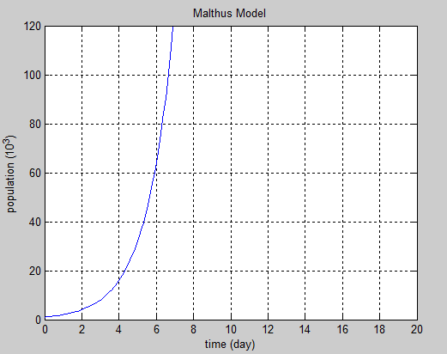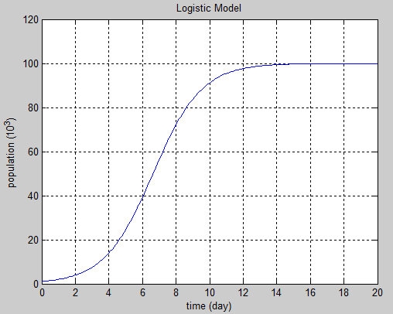
Figure1: Mathus Model Figure2: Logistic Model

1.2 Logistic Model
Considering the factors of competition between members of different organisms due to the limiting life place, food and living space, Logistic model adds a limiting factor, $(1-\frac{x}{N})$, in the differential equation, and the carrying capacity in the ecosystem is N. The group initial natural growth rate, r, will declines when the population grow. Once the biological moment grows to N, the group will stop growing. Differential equations:
$\left\{\begin{aligned}\frac{dx}{dt}=r(1-\frac{x}{N})x \\ x\left(0\right)=x_{0}\end{aligned}\right.$ ②
$\frac{x}{N}$ can be understood as occupied resource, and$\left(1-\frac{x}{N}\right)$ can be understood as available resource.
The solution of the equation above:
$x\left(t\right)=\frac{Nx_{0}e^{rt}}{x_{0}\left(e^{rt}-1\right)+N}$

1.3 Lotka-Volterra Model
In the 40 s of the 20th century, on the basis of the single-species model, the Lotka-Volterra double population competition model was put forward by Lotka and Volterra. The model sets the following variables and parameters:
$x_{1}, x_{2}$: the population quantity of species1 and species2
$N_{1}{,N}_{2}$: the environmental capacity of species1 and species2
$r_{1}, r_{2}$: the natural growth rate of species1 and species2
$m_{1}$: the coefficient competition of species2 to species1, means the resource used by one individual of species2 amount to $m_{1}$ individuals of species1
$m_{2}$: the coefficient competition of species1 to species2, means the resource used by one individual of species1 amount to $m_{2}$ individuals of species2
When the two species compete and use the same resource, the factor $\frac{x}{N}$ should add the factor of the resource occupation of competitive species. The differential equation:
$\left\{\begin{aligned}{x_{1}}^{'}\left(t\right)=r_{1}x_{1}\left(1-\frac{x_{1}+m_{1}x_{2}}{N_{1}}\right) \\ {x_{2}}^{'}\left(t\right)=r_{2}x_{2}\left(1-\frac{x_{2}+m_{2}x_{1}}{N_{2}}\right)\end{aligned}\right.$③

The root of differential equation has some feature:
Setting the initial point as $t=0$, then:
- When $m_{1}N_{2}$<$N_{1}$and $m_{2}N_{1}$<$N_{2}$,whatever the initial point is, when t→∞, then root→($\frac{N_{2}-m_{2}N_{1}}{1-m_{1}m_{2}} , \frac{N_{1}-m_{1}N_{2}}{1-m_{1}m_{2}}$), which means two species both exists. (the arrow means approach to)
- When $m_{1}N_{2}$<$N_{1}{ and m}_{2}N_{1}$>$N_{2}$, whatever the initial point is, when t→∞, then root→($N_{1}, 0$), which means the second one will be weed out；
- When $N_{2}$>$N_{1}$ and $m_{2}N_{1}$<$N_{2}$,whatever the initial point is, when t→∞, then root→($0, N_{2}$), which means the first one will be weed out；
- When $m_{1}N_{2}$>$N_{1}$ and $m_{2}N_{1}$>$N_{2}$, when t→∞, then root→($0, N_{2}$) or ($N_{1}, 0$), which balance point will the root tend to be, is determined by the initial condition.

1.4 Volterra Predation Relation Model
Volterra etc. not only put forward the competition model, but also raising the predator-prey model. The model sets the following variables and parameters:
$x$: the population quantity of prey
$y$: the population quantity of predation
r: the inherent growth rate of prey
d: the inherent death rate of predation
a: the capacity coefficient of predation grabbing the prey
b: the capacity coefficient of prey supporting the predation
Differential equation:
$\left\{\begin{aligned}x^{'}(t)=x(r-ay) \\ y^{'}(t)=y(-d+bx)\end{aligned}\right.$④
The solutions of the equation are two periodic functions.
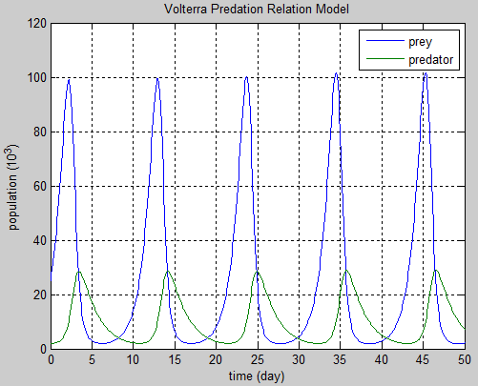
Figure3: Volterra Predation Relation Model

- The somatic cells - tumor cells relation model
Considering the tumor cells acts as an invasive species in the ecosystem, and compete with somatic cell for resources, so the competition model is an appropriate model to simulate the relationship between tumor cells and somatic cells. We set${ x}_{1}$ as the population of tumor cells, $x_{3}$ as the population of somatic cells. The rest of the parameters settings:
$N_{1}$: the environmental capacity of tumor cells in the tissue
$N_{2}$: the environmental capacity of bifidobacteria in the tissue
$N_{3}$: the environmental capacity of somatic cells in the tissue
$m_{1}$: the coefficient competition of somatic cells to tumor cells
$m_{3}$: the coefficient competition of tumor cells to somatic cells
$r_{1}$: the natural growth rate of tumor cells
$r_{3}$: the natural growth rate of somatic cells
$\left\{\begin{aligned}{x_{1}}^{'}\left(t\right)=r_{1}x_{1}\left(1-\frac{x_{1}+m_{1}x_{3}}{N_{1}}\right) \\ {x_{3}}^{'}\left(t\right)=r_{3}x_{3}\left(1-\frac{x_{3}+m_{3}x_{1}}{N_{3}}\right)\end{aligned}\right.$⑤
When ecological system is healthy, the immune system can limit environmental capacity of tumor cell in a low scope ($N_{1}$is very low). Meeting the conditions$m_{1}N_{3}$>$N_{1 }$and$m_{3}N_{1}$<$N_{3}$ (condition 3 in Lotka-Volterra Model), the somatic cells have a huge survival advantage than tumor cell. As time increases, the tumor will be eliminated. But when the body ecosystem is defected and the body's immune system is weak, the tumor cells’ allowing maximum survival number will greatly increase and then somatic cells will be eliminated ($m_{1}N_{3}$<$N_{1}$ and $m_{3}N_{1}$>$N_{3}$ condition 2 in Lotka-Volterra Model). Then, the solid tumor will grow in the tissue ecosystem.
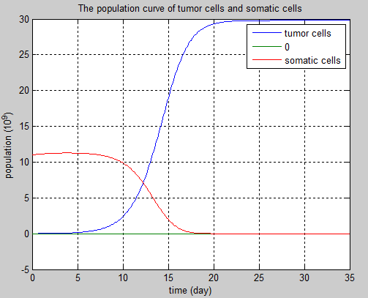
Figure4: The population change when the body's immune system is weak. $m_{1}N_{3}$<$N_{1}$ and $m_{3}N_{1}$>$N_{3}$. Solid tumor cells gradually increase to the environmental capacity $N_{1}$, and somatic cells’ population gradually declines to zero. This model is based on the Lotka-Volterra Model, and explains how the solid tumor grow when tumor cells compete with somatic cells.

- Bifidobacteria-tumor cells relation model
3.1 Basic predator-prey relation model
When bifidobacteria targeted in tumor tissues, for one thing, bifidobacteria secrete apoptin to promote tumor cells apoptosis. So for the tumor cells, bifidobacterium is equivalent to a predator in the tissue ecosystem; for another thing, bifidobacterium is strictly anaerobic bacterium, when tumor cells’ population decreases and then the oxygen concentration increases, the growth of bifidobacterium is suppressed and it will die gradually. So the relationship between the bifidobacteria and the tumor cells seems to be a parasitic relationship.
Variables and parameters set as follows:
$x_{1}$: the population of tumor cells
$x_{2}$: the population of bifidobacteria
$r_{1}$: the natural growth rate of tumor cells
$r_{2}$: the natural growth rate of bifidobacteria in best hypoxia condition
$R_{2}$: the death rate of bifidobacteria in nontumorous condition (the oxygen concentration is high )
$N_{1}$: the environmental capacity of tumor cells
$N_{2}$: the environmental capacity of bifidobacteria
$n_{1}$: the coefficient competition of bifidobacteria to tumor cells
$n_{2}$: the coefficient competition of tumor cells to bifidobacteria
$a$: the predation coefficient of bifidobacteria to tumor cells (related to the ability of apoptin to kill tumor cells)
$b$: unit adjust factor（adjustment for unit difference, take 1×10⁹ as unit）
Considering the tumor cell population decline will cause the oxygen concentration increasing and changing the natural growth rate of the bifidobacteria, the number of tumor cells and the natural growth rate of the bifidobacteria can be roughly associated with function image as follows.
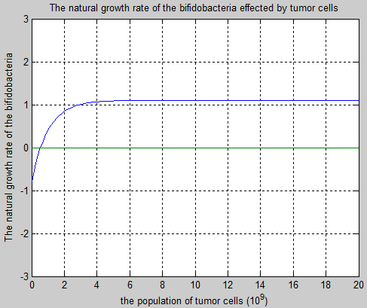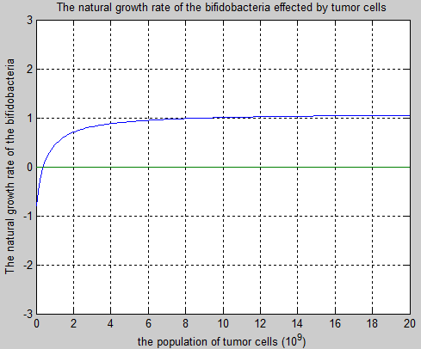
Figure5: The natural growth rate of the bifidobacteria change with the population of solid tumor cells. When the population of solid tumor cells is high, the concentration of oxygen will be low, and the natural growth rate of the bifidobacteria will be high.
The basic functions, which images are consistent to the images above, are separated into two kinds, one is exponential function, the other one is inverse proportional function. Considering the exponential function changes faster at the beginning, which is more accordant to the actual situation, we establish the exponential function model as follows:
$$r=r_{2}-e^{-\frac{x_{1}}{b}+ln\left(r_{2}+R_{2}\right)}$$
$r$: the natural growth rate of bifidobacteria
When tumor cells amount $x_{1}→∞$, then$r→r_{2}$
When tumor cells amount $x_{1}→0$, then $r→R_{2}$
Then we establish the Bifidobacterium-tumor model based on the Volterra Predation Relation Model.
The differential equation of bifidobacteria and tumor cells:
$\left\{\begin{aligned}{x_{1}}^{'}\left(t\right)=x_{1}\left[r_{1}\left(1-\frac{x_{1}+n_{1}x_{2}}{N_{1}}\right)-ax_{2}\right] \\ {x_{2}}^{'}\left(t\right)=x_{2}\left(r_{2}-e^{-\frac{x_{1}}{b}+ln\left(r_{2}+R_{2}\right)}\right)\left(1-\frac{x_{2}+n_{2}x_{1}}{N_{2}}\right)\end{aligned}\right.$⑥
In the first equation there are environmental resistance$1-\frac{n_{1}x_{2}}{N_{1}}$ and predation factor$ax_{2}$；
In the second equation there are environmental resistance$1-\frac{n_{2}x_{1}}{N_{2}}$ and oxygen concentration restriction factor $r_{2}-e^{-\frac{x_{1}}{b}+ln\left(r_{2}+R_{2}\right)}$
With the appropriate parameter values and the initial point taking in, the image:
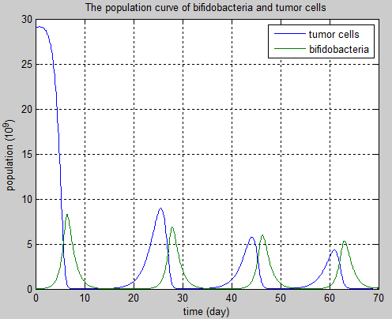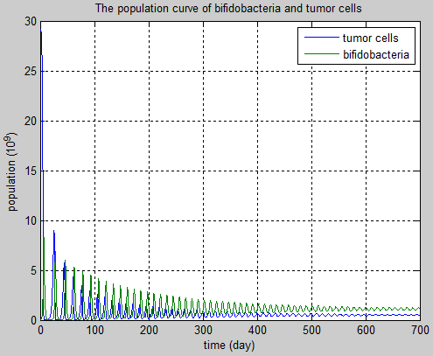
Figure6: The population curve of bifidobacteria and tumor cells based on Volterra Predation Relation Model.
It can be viewed in figure6, the tumor cells number (high at t=0) and bifidobacteria population (low at t=0) is a gradually reducing amplitude volatile relationship. When time increases, the population of both kinds of cells approaching to a lower value. So, if the parameter values are fit, bifidobacteria can limit tumor cells in a low level.

3.2 Prey Dependence Functional Reacting Model
For predators, when the population of prey increases, predator will get more food in unit time and eventually tend to be a maximum value. Volterra Predation Relation Model does not reflect this point. In order to fix this deficiency, Holling etc. put forward Prey Dependence Functional Reacting Model at 1965. Considering tumor cells can not supply nutrition to bifidobacteria as true preys do, we select Holling Ⅱ Type Functional Reacting Model to reflect the saturation condition of tumor cells. It means when the population of tumor cells is low, bifidobacteria will kill more tumor cells in unit time when the population of tumor cells increase, but when the population of tumor cells is at a high level, the number of tumor cells killed by bifidobacteria in unit time will approach to a maximum value. So, $ax_{1}x_{2}$ changes into $\frac{ax_{1}x_{2}}{b+x_{1}}$, and differential equations ⑥ changes to be the following equations:
$\left\{\begin{aligned}{x_{1}}^{'}\left(t\right)=x_{1}r_{1}\left(1-\frac{x_{1}+n_{1}x_{2}}{N_{1}}\right)-\frac{ax_{1}x_{2}}{1+x_{1}} \\ {x_{2}}^{'}\left(t\right)=x_{2}\left(r_{2}-e^{-\frac{x_{1}}{b}+ln\left(r_{2}+R_{2}\right)}\right)\left(1-\frac{x_{2}+n_{2}x_{1}}{N_{2}}\right)\end{aligned}\right.$⑦
With the appropriate parameter values and the initial point taking in, the image:
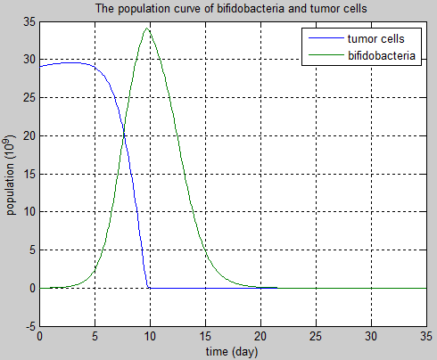
Figure7: The population curve of bifidobacteria and tumor cells based on Holling Ⅱ Type Functional Reacting Model.
In figure7, the tumor cells slowly increase at early time. As the population of bifidobacteria rising, the population of tumor cells declined sharply, then the population of bifidobacteria goes down after it get to the maximum value. Finally, the population of bifidobacteria and tumor cells tend to zero. In this model, with the appropriate parameter, bifidobacteria can reduce the amount of tumor cells, then the population of bifidobacteria gradually drop to zero.

- Tumor cell - bifidobacterium-somatic cell model
We consider the tumor tissue as a homogeneous environment, there exists a great number of tumor cells and a small number of somatic cells, when a few of bifidobacteria parasitize in tumor tissue, the relationships of these three kinds of cells show as follows.
- Tumor cells compete with somatic cells, and bifidobacteria prey on tumor cells.
- Bifidobacteria compete with somatic cells, restricted by oxygen.
- Somatic cells compete with tumor cells and bifidobacteria.
Assuming the somatic cells can multiply, setting the natural growth rate as $r_{3}$.
The differential equation based on Holling Ⅱ Type Functional Reacting Model:
$\left\{\begin{aligned}{x_{1}}^{'}\left(t\right)=x_{1}r_{1}\left(1-\frac{x_{1}+n_{1}x_{2}+m_{1}x_{3}}{N_{1}}\right)-\frac{ax_{1}x_{2}}{b+x_{1}} \\ {x_{2}}^{'}\left(t\right)=x_{2}\left(r_{2}-e^{-\frac{x_{1}}{b}+ln\left(r_{2}+R_{2}\right)}\right)\left(1-\frac{x_{2}+n_{2}x_{1}+L_{2}x_{3}}{N_{2}}\right) \\ {x_{3}}^{'}\left(t\right)=r_{3}x_{3}\left(1-\frac{x_{3}+m_{3}x_{1}{+L}_{3}x_{2}}{N_{3}}\right)\end{aligned}\right.$⑧
With the appropriate parameter values and the initial point taking in, the image shows as follows.
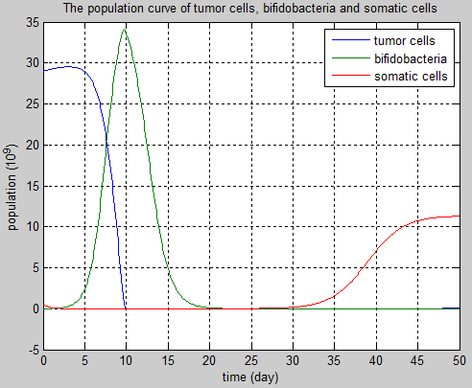
Figure8: The population curve of tumor cells, bifidobacteria and somatic cells. Under suitable parameters, the population of tumor cells decreases from a high level while the population of bifidobacteria goes up and then decreases and tend to zero. The population of somatic cells increases after the population of tumor cells and bifidobacteria come to zero. This model shows bifidobacteria can be used to kill the tumor cells and bifidobacteria will not leave for a long time in the tissue after tumor cells die off.

From the model, tumor cells are killed by bifidobacteria and the population of tumor cells decreases. Then the growth of bifidobacteria will be restrained for rising of oxygen concentration. When the population of competitors declines and the improvement of the environment, the population of somatic cells will constantly increase, finally recover to normal level. So in this model, bifidobacteria can be used to kill the tumor cells and they will not stay for a long time in the tissue after tumor cells die off.

Parameters List
$t$: time
$x_{1}$: the population of tumor cells
$x_{2}$: the population of bifidobacteria
$x_{3}$: the population of somatic cells
$r_{1}$: the natural growth rate of tumor cells
$r_{2}$: the natural growth rate of bifidobacteria in best hypoxia condition
$r_{3}$: the natural growth rate of somatic cells
$R_{2}$: the death rate of bifidobacteria in nontumorous condition (the oxygen concentration is high )
$N_{1}$: the environmental capacity of tumor cells
$N_{2}$: the environmental capacity of bifidobacteria
$N_{3}$: the environmental capacity of somatic cells
$m_{1}$: the coefficient competition of somatic cells to tumor cells
$n_{1}$: the coefficient competition of bifidobacteria to tumor cells
$n_{2}$: the coefficient competition of tumor cells to bifidobacteria
$L_{2}$: the coefficient competition of somatic cells to bifidobacteria
$L_{3}$: the coefficient competition of bifidobacteria to somatic cells
$m_{3}$: the coefficient competition of tumor cells to somatic cells
$a$: the predation coefficient of bifidobacteria to tumor cells (related to the ability of apoptin to kill tumor cells)
$b$: unit adjust factor（adjustment for unit difference, take 1×10⁹ as unit）
Reference
[1] Hritonenko N, Yatsenko Y. Mathematical Models of Biological Populations[M]// Mathematical Modeling in Economics, Ecology and the Environment. Springer US, 2013:133-156.
[2] Huang Jicai. Bifurcations in a predator-prey system with Holling type-IV functional response [J]. Journal of Central China Normal University: natural science edition, 2002, 36(1):3-10.
[3] Wu Chunguang. A class of predator-prey population dynamics model and Numerical simulation [D]. Minzu University of China, 2009.
[4] Sun Duoru. Mathematical Model of biological population [D]. Shandong University, 2007.

