Assembly instructions
Growth facility - Jake Levi - Cambridge iGEM
- Verify that all electronic circuits work individually before building them inside the box, including making sure that the Raspberry Pi has the correct code on it (if you are not remote-accessing). For help in interacting with the Twiter API, there are lots of useful tutorials about the ‘Tweepy’ Python module. In order to schedule your script to run autonomously at specified intervals after startup, there are lots of useful tutorials about using the ‘Cron’ utility and ‘crontab’. For help connecting your Raspberry Pi to Eduroam, see my Instructables tutorial: http://www.instructables.com/id/Access-Eduroam-on-a-Raspberry-Pi-in-Cambridge/
- Laser cut the box frame using the attached .DXF files
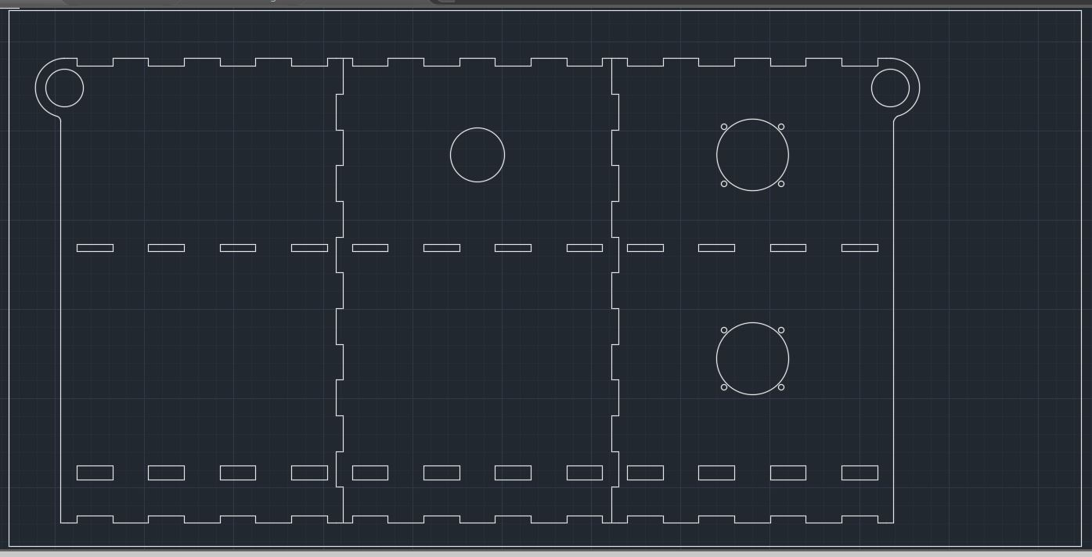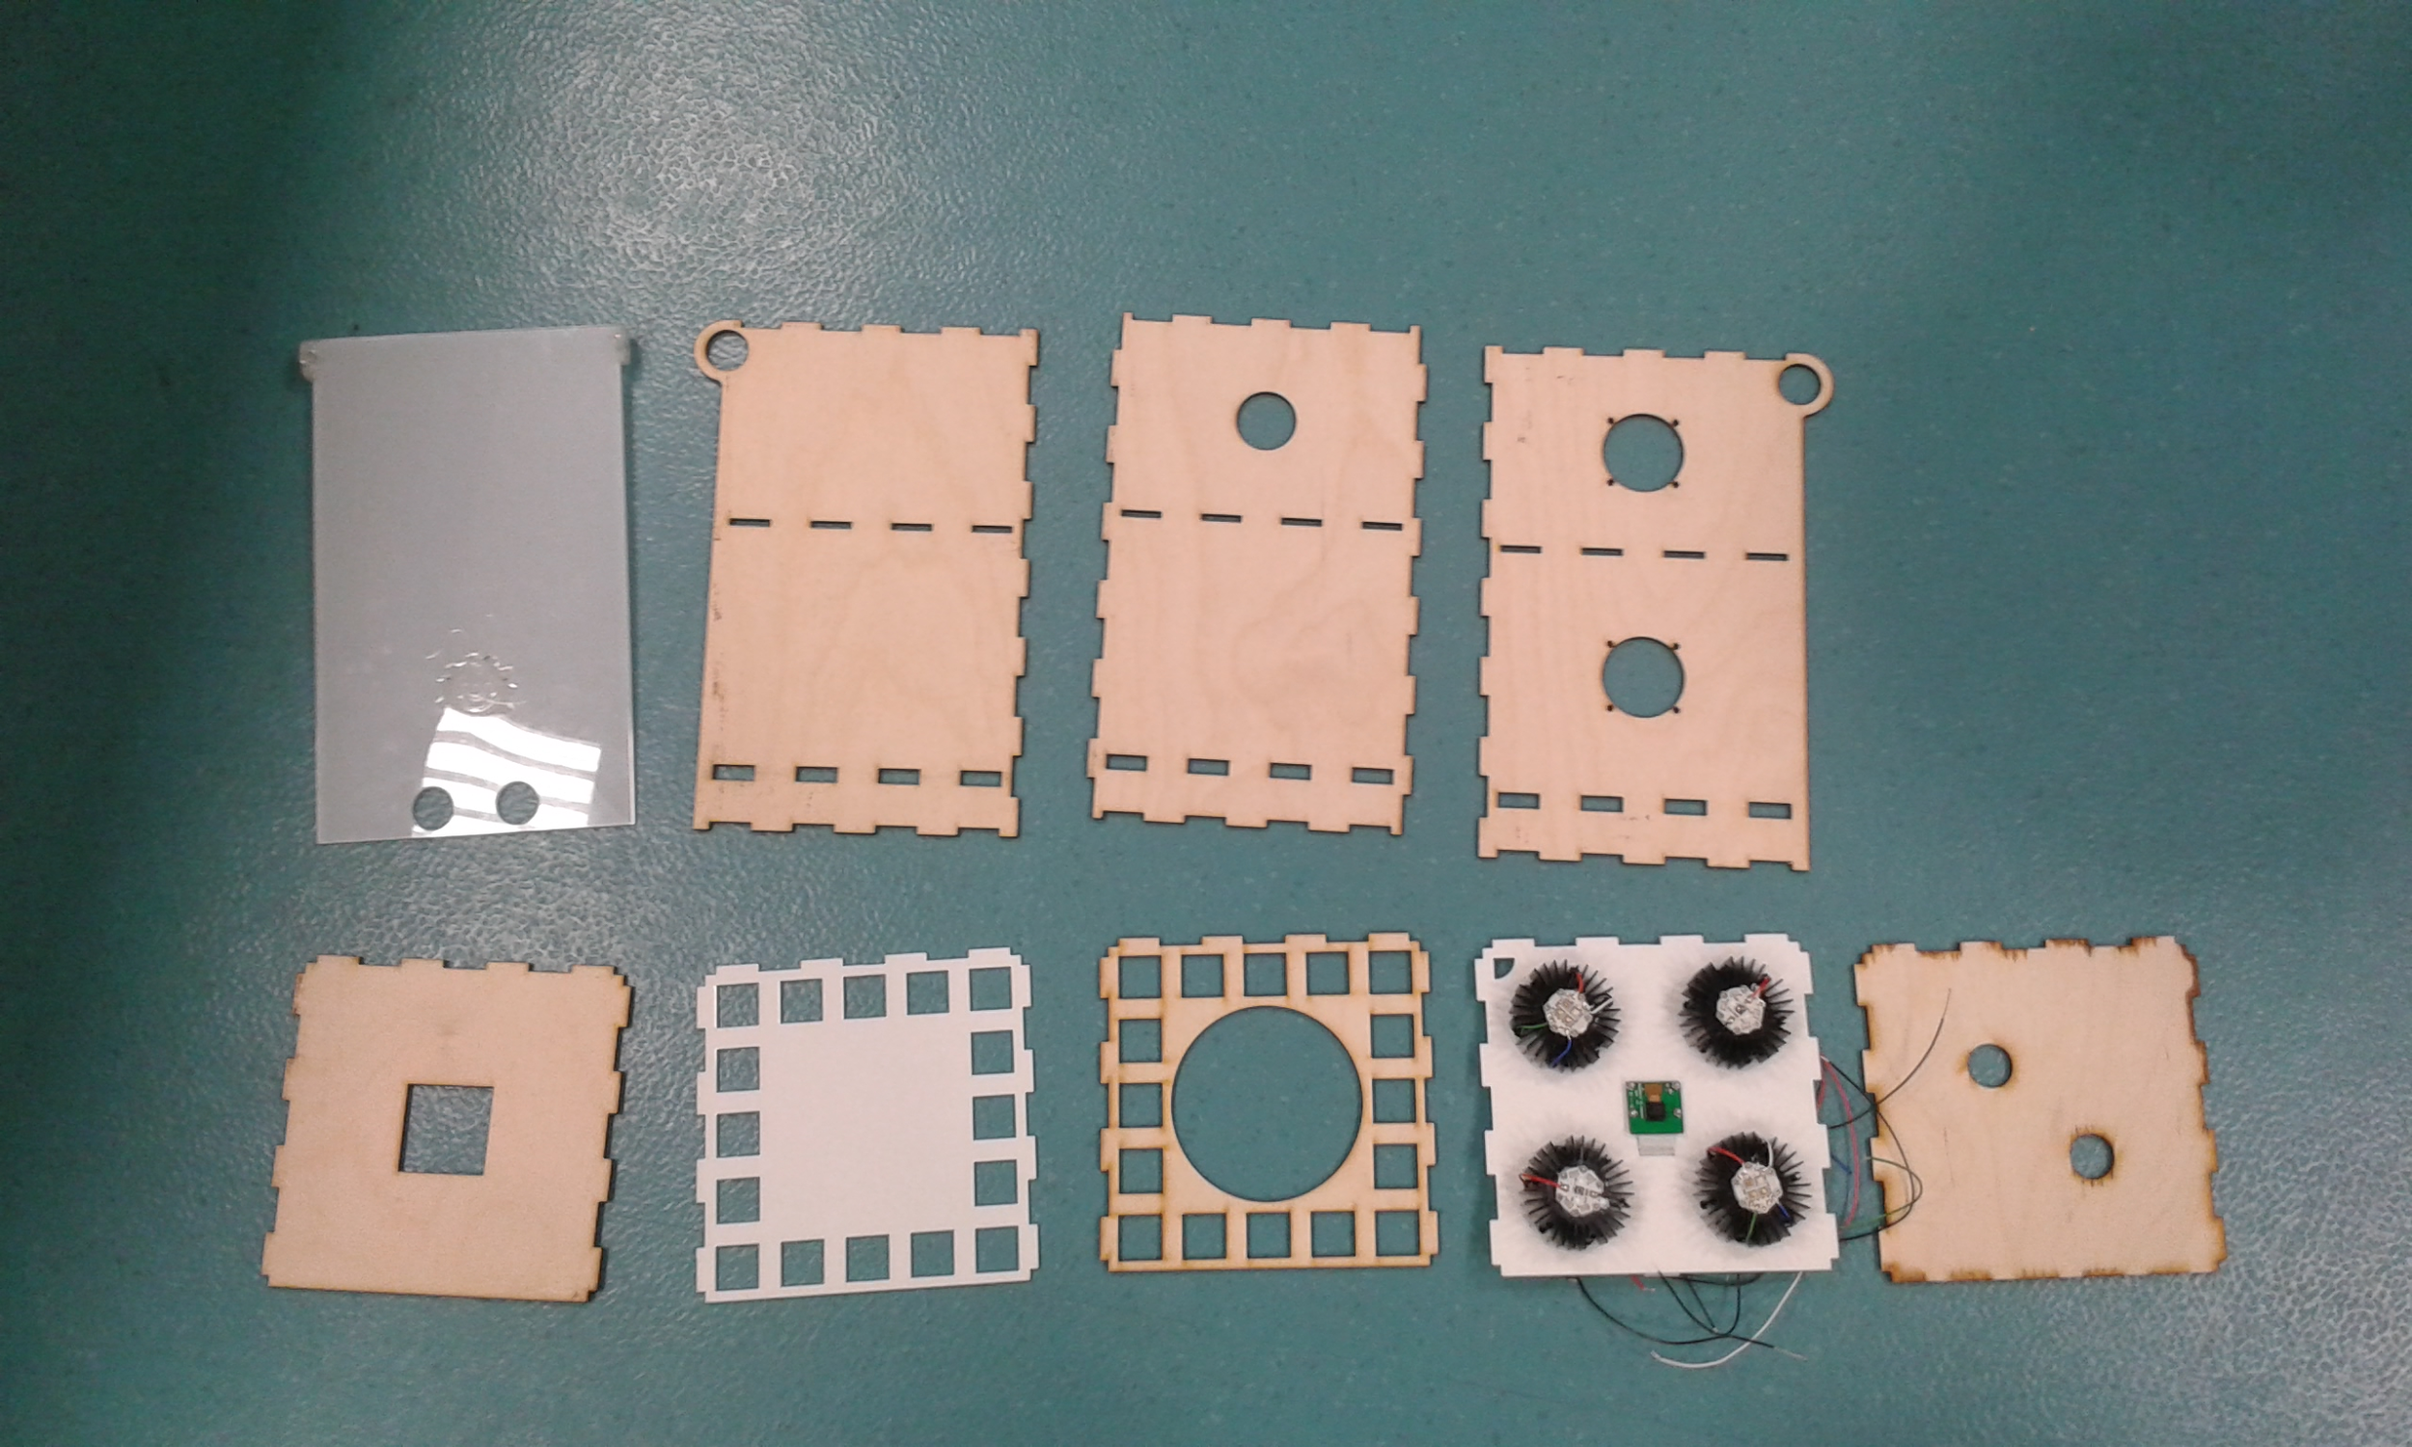
- Prepare LEDs, by first applying thermal adhesive to the heatsinks, and then screwing in the LEDs using M3 screws. At the same time, prepare the Peltier element, by applying thermal adhesive to the surface of the 30mm heatsink, and a blob of 2-part epoxy superglue in each corner
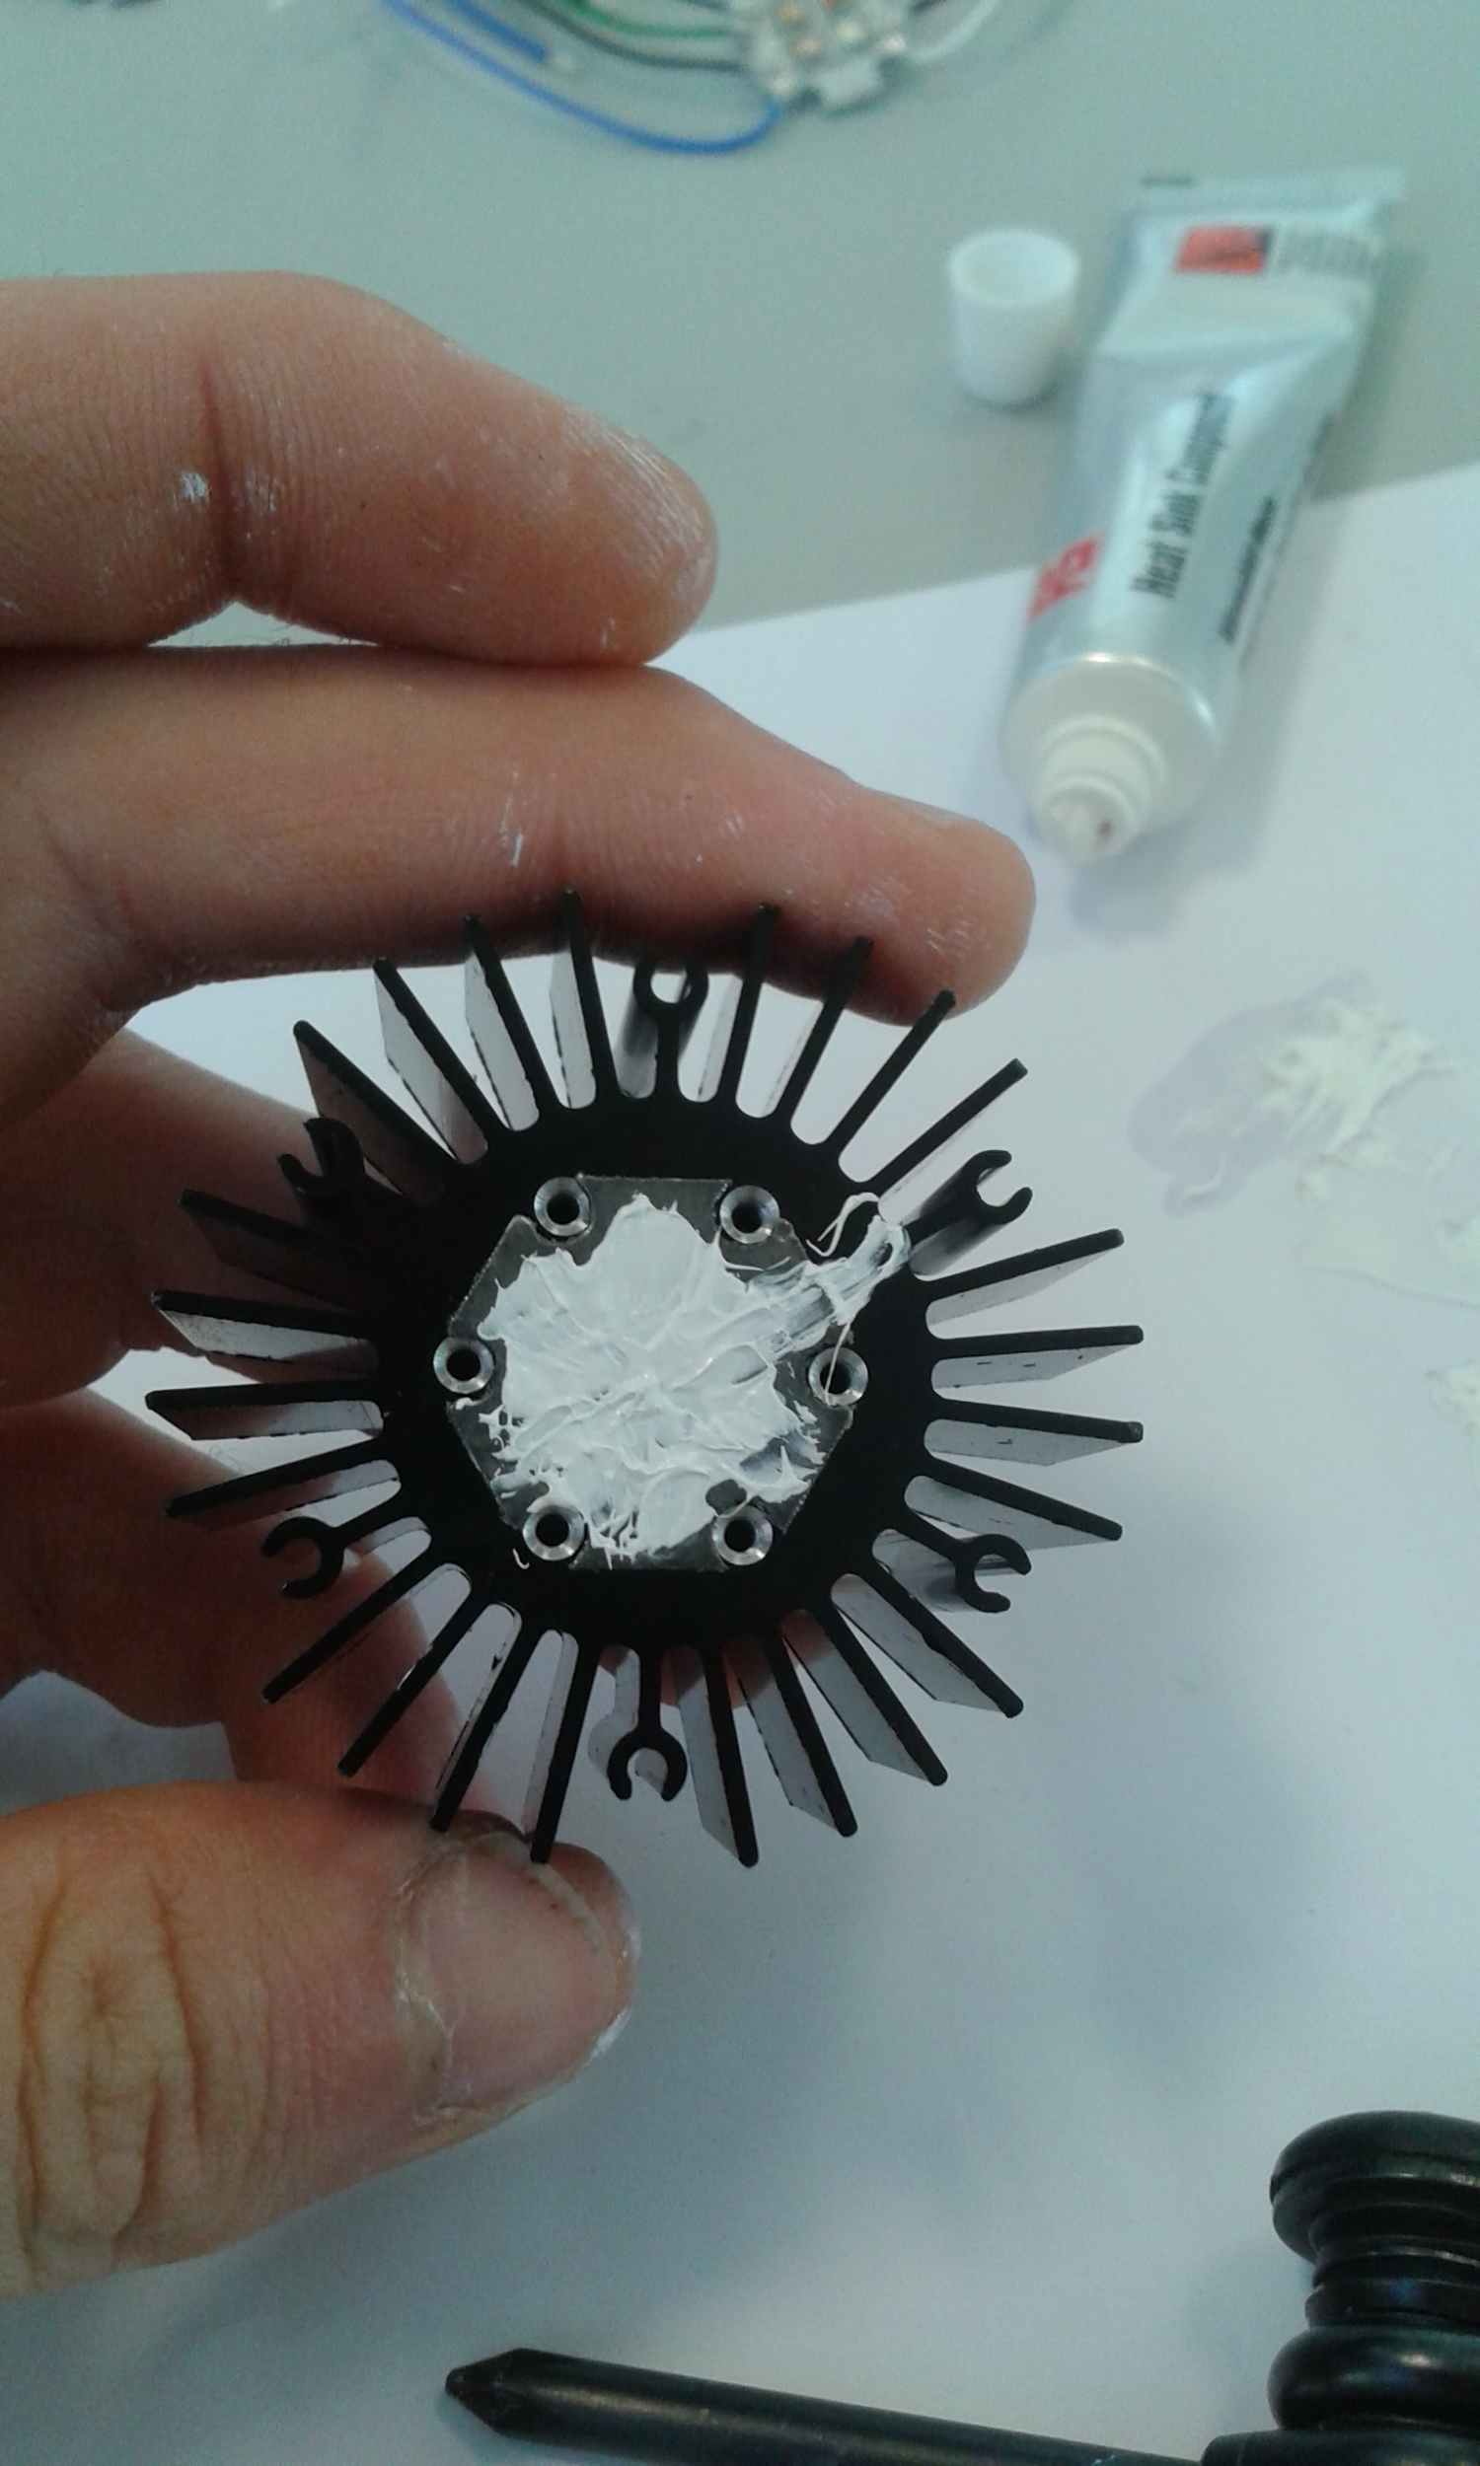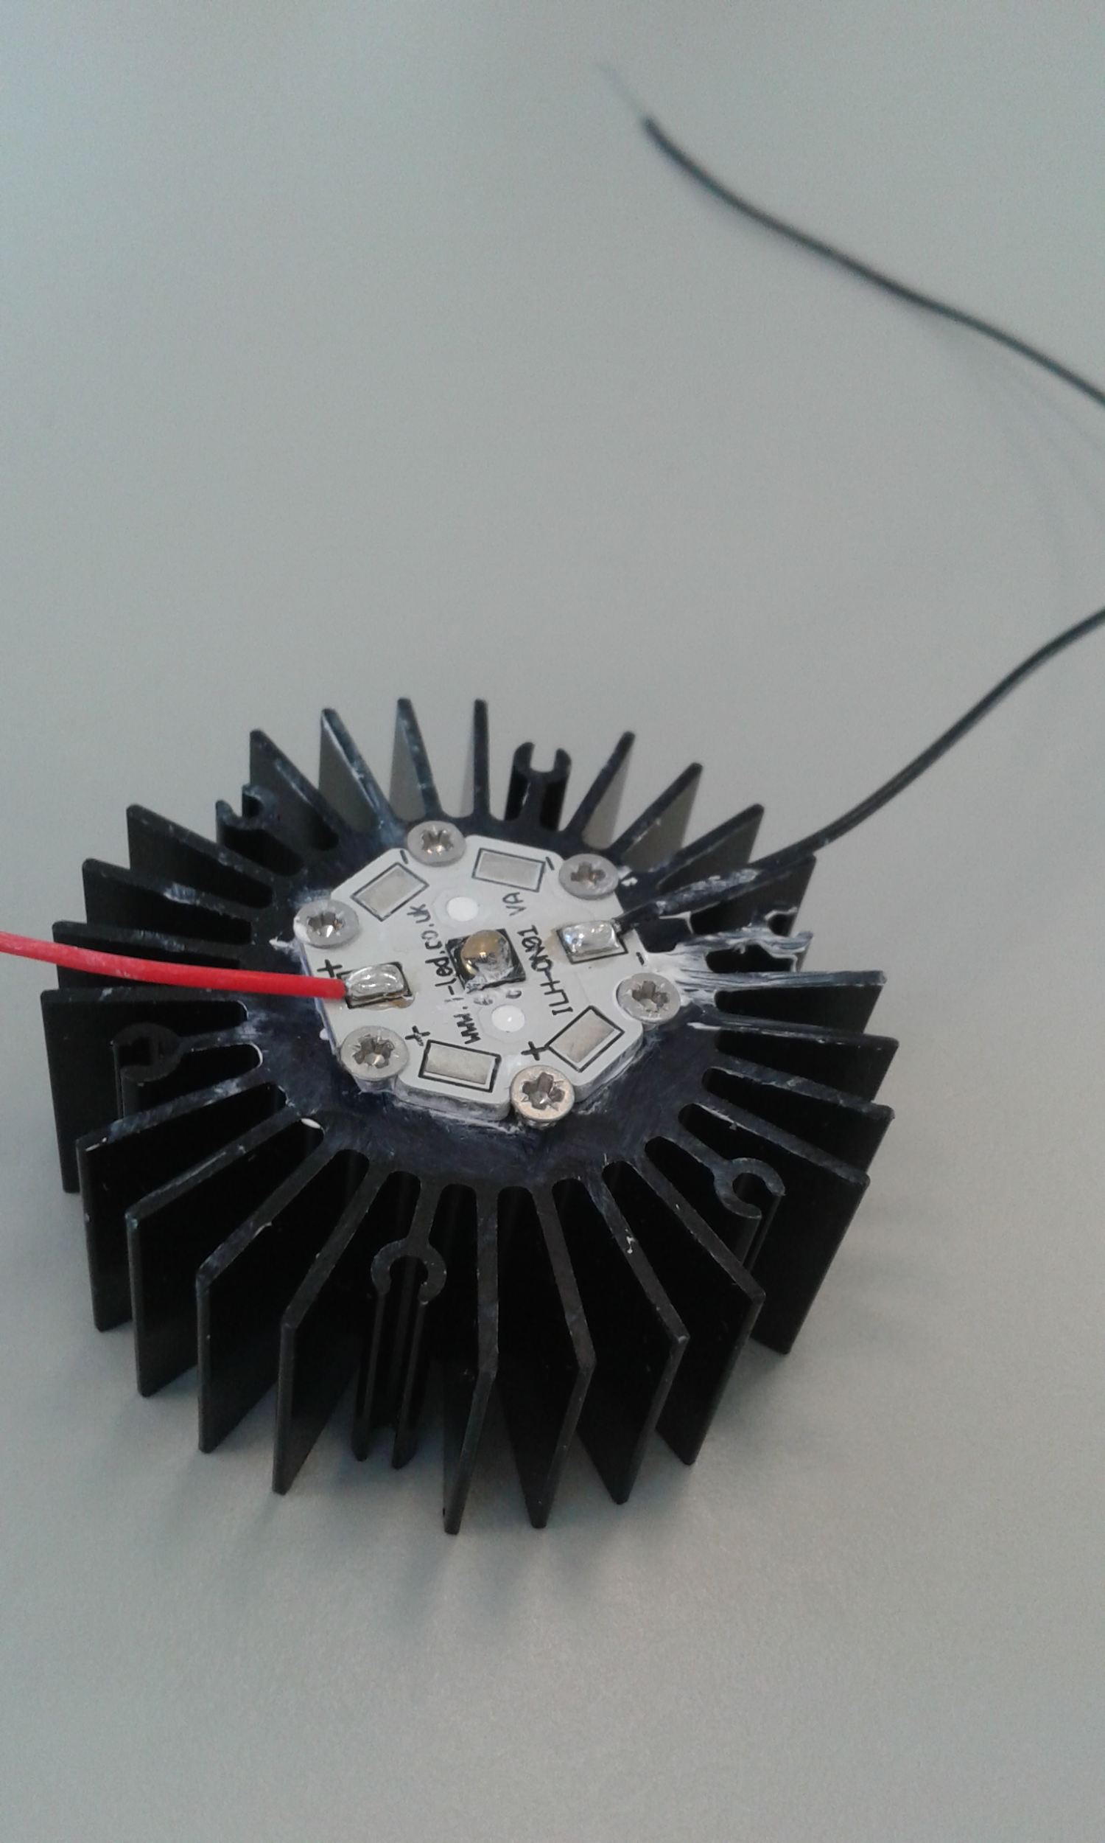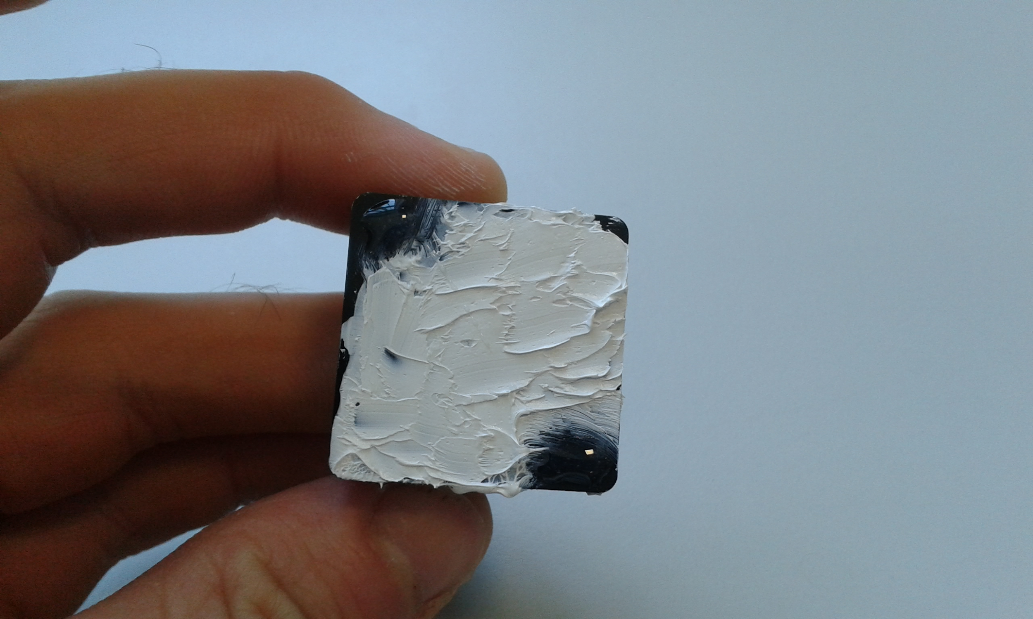
- Prepare the upper shelf and right-hand wall as shown in the picture below. The 5V fans will each need 4 M3x10mm screws, and 4 M3 hex nuts. The LEDs will require a further 4 M3 screws each (16 in total). The Raspberry Pi camera module will require 4 M2x10mm screws, and 4 M2 hex nuts. Note that depending on the parts you are using, you may wish to solder extra wire lengths to your wires before completing the rest of this step
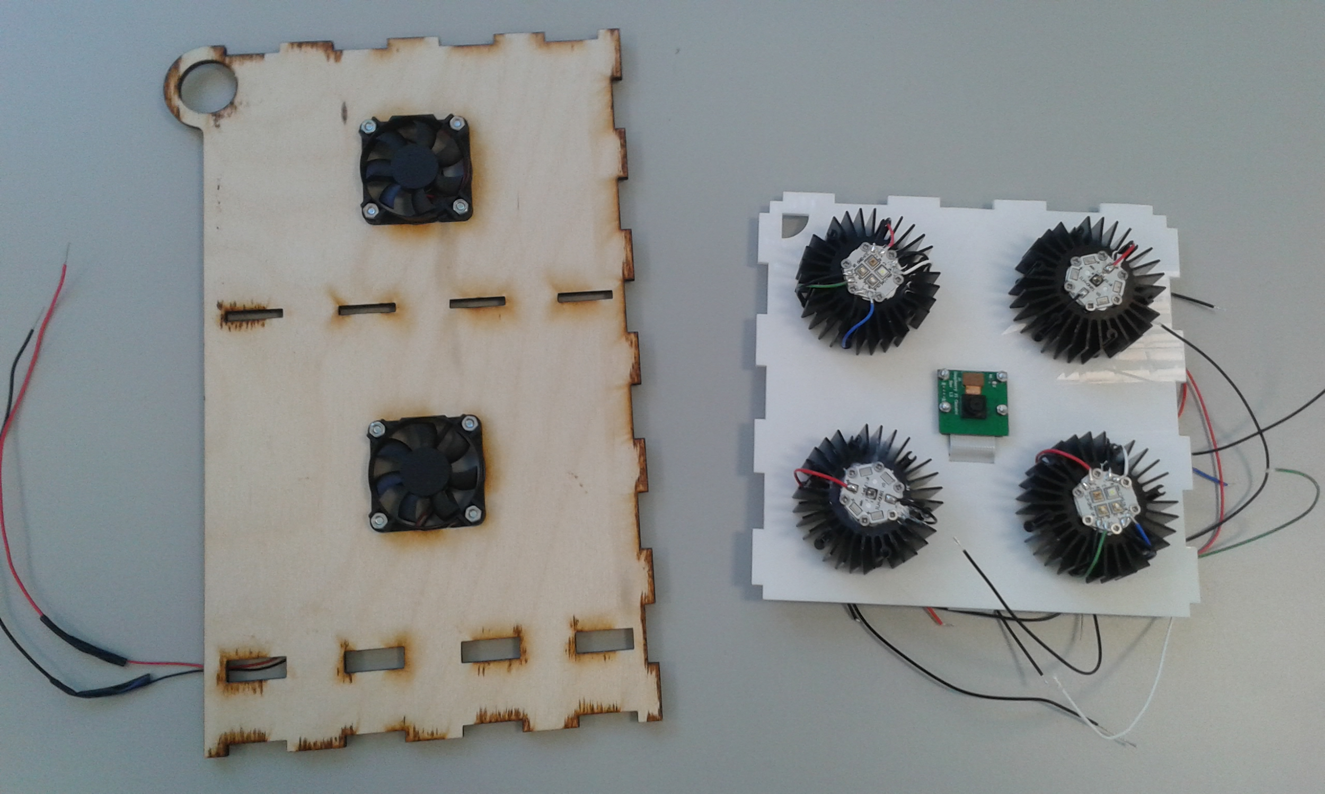
- Assembling the box:
  - Glue the hinges on the door
  - Glue the 2 halves of the lower shelf together
  - Glue the upper and lower shelves to the back of the box
  - Glue on the sides, holding the door in place. (The bottom plate can be glued on later, after the Peltier has been wired up. It is recommended that the top plate not be glued on at all, to allow access to the electronics enclosure, hence the inclusion of finger holes)
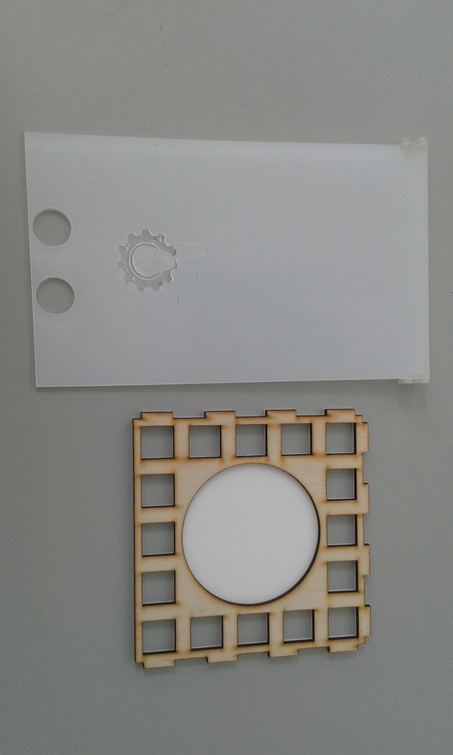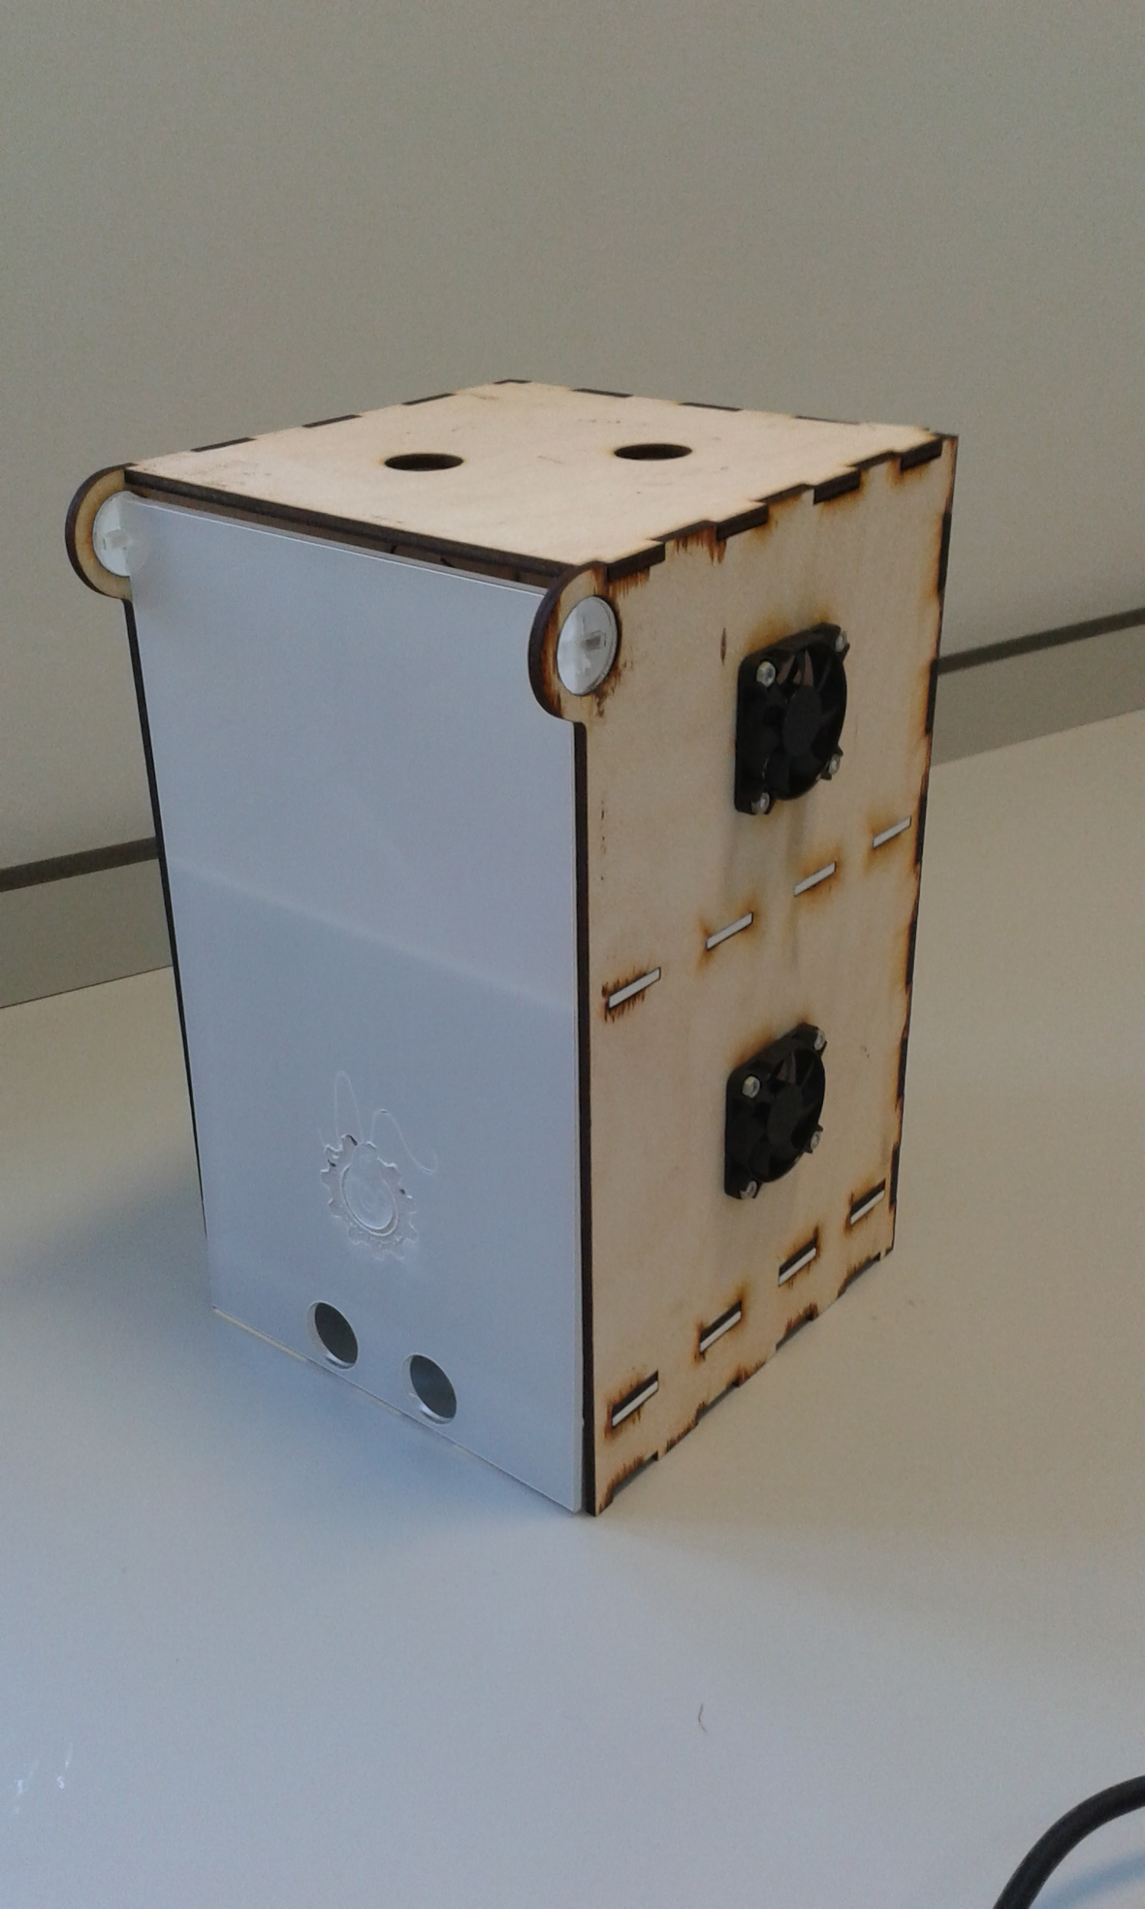
- Electronics:
  - Solder any extra wire lengths to components that you will need, before wiring them up in the box
  - Wire up the Arduino circuits as shown in the circuit diagrams below. NB: this might get messy. NB also that a 1k resistor should be connected between each Arduino output pin and transistor gate (this is to prevent dangerously high currents being drawn through the Arduino due to the transistors’ stray capacitance)
  - Connect the Raspberry Pi to the camera using the ribbon cable
  - Provide power to the Arduino and Raspberry Pi using the wiring hole at the back of the electronics enclosure
  - Connect the switch-mode power supply and LED driver to the live, neutral and earth cables of your main cable (make sure that there is no voltage supplied to the cable when this is done. Also note that it is recommended that the LED driver be soldered to the live and neutral cables)
  - Connect the outputs of the SMPS and LED driver to the 2 different rails of the breadboard, which should share a common ground with the Arduino
